**TRENDS IN TRANSFORMER LIFE-CYCLE MANAGEMENT ON-LOAD TAP-CHANGER AND TRANSFORMER ACCESSORIES**

W. FLEISCHMANN, Maschinenfabrik Reinhausen GmbH – MR, Germany[1]

**ABSTRACT**

Huge and outdated substations, various transformer brands and sizes, diverse tap-changer types, many transformer accessories and operational concepts, load behavior and ambient influences are – among others – a result of the enormous increase of energy demand within the last 30 years. In order to keep operation reliability and to integrate obsolete systems into modern substation concepts, it is of vital importance to develop **Asset-** **Management** and **Maintenance** Strategies.

Considering the installed base and technical data of transformers, a concept to calculate the importance and condition of the specific asset is necessary. Plant **Maintenance** management in consideration of importance and condition of the transformer is an efficient tool.

Key factors in accordance with operator standards have to be defined to review condition and importance of the particular transformer. Based on diagnostic measures and arithmetic systems, criteria with various weighting systems can be defined. The criteria illustrate a ranking of transformers. This ranking is a basis for **Maintenance**, availability, cost management and budget planning.

Uncountable transformer and OLTC test systems are available in the market. Reliability and accuracy of test systems are certainly the main criteria of test systems. Having measurement values is essential for the diagnosis but the interpretation of these values and the resulting recommendation for **Asset-Management** is the most difficult and most important part of transformer diagnostic programs. It is essential to proceed on the basis of the diagnostics results, interpreting the respective actions in the right way.

**1. Introduction**

As a result of an enormous increase of energy demand the installed base of power transformers is growing faster than ever before. Strategic planning for transformer capacity expansion is an important chapter of the utility and industry sectors. As capacity planning for new transformers is - among other criteria - based on the already installed transformer capacity, it is even more important to consider modern strategies how to manage the existing assets.

Figure 1

Approx. number of installed transformers in Middle East

Source: MR Market Study

The bigger and older the entire transformer fleet becomes, the more important it is to consider Transformer Life-Cycle Management during the whole life span of the equipment. This paper puts a main focus on on-load tap-changer equipment and transformer accessories.

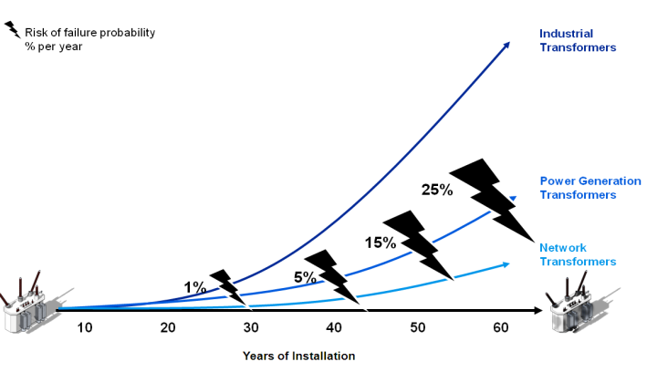

Figure 2

Risk of failure probability in % per year

Source: ABB TrafoAssetManagementTM

CIGRE WG 12-05 (1983) An internal survey on failures in large power transformers”

**2. Asset-Management and Maintenance-Strategies for transformer OLTC and Accessories**

Due to the enormous increase of the installed transformer base during the last 30 years, a clear strategy has to be developed how to manage the existing assets considering availability, reliability and cost efficiency.

Suitable Strategy means to detect any irregularities before they cause failures on the operational system.

Life-Cycle management starts with installation and commissioning of the transformer. Commissioning assures the proper function and will also provide a fingerprint (measurement values) for any further test and diagnostics.

The following steps of the commissioning procedure could be considered necessary for future Life-Cycle Management:

**Transformer:**

* Turn Ratio test
* Static Resistance Measurement
* Breakdown Voltage and Water Content of Transformer oil

**On-Load Tap-Changer**:

* Dynamic Resistance Measurement
* Breakdown Voltage and Water Content of OLTC Oil
* Electrical and mechanical test

**Transformer Accessories:**

* Verification of all Measurement Systems like OTI/WTI
* Verification of van control system
* Verification of protection systems
* Documentation of all above mentioned values

Every utility and transformer user should define a standard for the documentation of all assets including measured values and performed services.

**2.1. Maintenance Philosophies**

The overall **Asset-Management** strategy is based on different service philosophies considering importance and reliability of the respective components. Transformer operators usually select and define a combination of the following philosophies.

Risk based / event based **Maintenance**

Any inspection, repair or **Maintenance** work will be carried out only after a failure occurs. Within this philosophy the failure indicates the necessity for further steps. No predictive **Maintenance** plan is available.

Risk based **Maintenance** is definitely considered as a wrong strategy.

Time based **Maintenance** / Predictive **Maintenance**

The **Maintenance** steps are carried out within fixed intervals, time frames and criteria indicated by the original manufacturers and the respective operating manuals of the equipment. This philosophy offers easy planning (shut down times, spare parts) and improves the condition of the equipment.

Condition based **Maintenance**

Any services and **Maintenance** work is carried out based on the condition of the equipment. The right component shall be maintained at the right time. Fixed parameters and conditions have to be defined and set as references. The work has to be carried out if the reference levels are reached or if one or more parameters indicate the need of **Maintenance**. Planning of shutdown time and spare part availability needs attention. Sensors, test procedures and monitoring systems are necessary in order to know the condition.

Preventive **Maintenance**

Finally, and considering all aspects and philosophies, any **Asset-Management** plan or **Maintenance** strategy should be preventive and assure the reliability and proper function of the overall equipment.

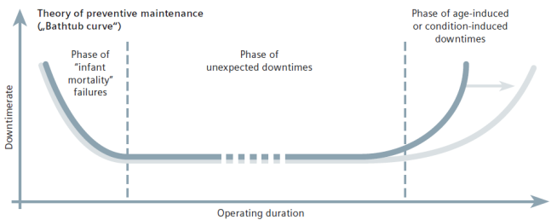

Figure 3

Theory of preventive **Maintenance** by Siemens TLMTM

NO **Maintenance**

(use of **Maintenance-Free** products)

If **Maintenance-Free** products are used for new projects or if **Maintenance**-**Free** products are installed as retrofit projects, then the **Maintenance-Free** strategy could be followed. The use of such **Maintenance**-**Free** products (e.g. Vacuum OLTC, Dehydrating Breather …) is part of modern **Asset-Management** strategies.

* 1. **Modern Asset-Management Strategies include:**
* Reliability Centered **Maintenance**
* Condition **Assessment**
* Strategy combined of time and condition based **Maintenance**
* Determination of the appropriate level of the necessary **Maintenance**
* Determination of the necessary task when to perform a **Maintenance**
* Training of **Maintenance** teams
* Replacement of components with longer **Maintenance** intervals
* End of life determination for assets
* Technically and economically optimized solutions for assets

**3. Criteria – Condition Assessment**

In some areas the capacity increase (installation of new transformers) was much more important / required than maintaining the existing assets. In such cases (lack of **Maintenance** and operating information) diagnostic tools are required in order to create a ranking and to know where to start.

In order to define an **Asset-Management** strategy or to combine the different **Maintenance** philosophies, a condition **Assessment** plan has to be developed.

For instance, integrated plant **Maintenance** covers the planning of required **Maintenance** measures for transformers (combination of the **Maintenance** philosophies) taking the following criteria into consideration:

Condition (examples)

* Age
* Number of operations
* Load factor
* Operational experience
* Noise level
* Annual operating hours
* Power transmission
* ***Diagnostic results***
* Service and supply of spare parts

Importance (examples)

* Consequences of outages
* Number of substitute devices
* Investment cost
* Power conversion
* Voltage level
* Voltage quality
* Availability
* Etc.

Based on a calculation the importance and condition INDEX can be defined in accordance with the following example:

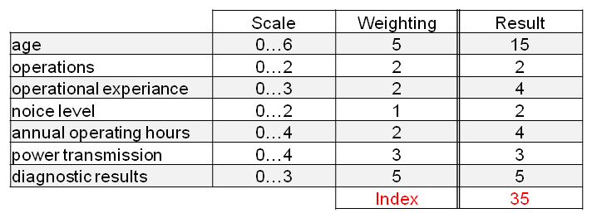

Figure 4

Transformer index

The evaluated index finally indicates the priority of **Maintenance** requirement for the assets in operation.

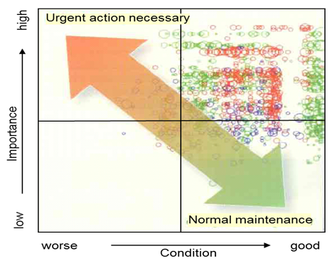

Figure 5

Classification of Assets

Source: BWK Magazine

**4. Transformer Accessories and OLTC Diagnostics for Assessment purposes**

As mentioned in chapter 3, among other criteria, diagnostic results are required in order to get a ranking about the condition of outdated transformers.

Beside diagnostics for the transformer itself, diagnostics in order to know the condition of the accessories and the tap-changer have to be carried out, too.

After any diagnostics, qualified partners with long term experience are necessary in order to develop an expertise and a respective **Maintenance-**strategy. It is essential to evaluate all diagnostic results in a professional way and to define a guide which preventive action/ **Maintenance** need to be done in accordance with the respective time intervals.

Any diagnostic measure and **Assessment** procedure will NOT replace **Maintenance** work.

The following steps should be considered for transformer accessories and OLTC **Assessment**.

* Documentation of design data / technical data and serial numbers of transformer and tap-changer
* Documentation of type and technical data of the transformer accessories
* Service history
* Visual inspection of whole system (damages / leakages etc.)
* Electrical Measurements (Dynamic Resistance Measurement)
* Standard Transformer Oil Tests (DGA, Breakdown Voltage, Moisture, Furanic Analysis)
* Standard OLTC Oil Test (Breakdown Voltage, Moisture)
* Functional test accessories (calibration bath, current simulator…)

**5. Modernization of Power Transformers**

Professional routine **Maintenance** and **Modernization** of transformers is a significant element during the lifecycle of transformers.

Beside routine **Maintenance** requirements, criteria for transformer **Modernization** are:

* General overhaul of a transformer for another lifespan of 25 years and longer
* Aging of the transformer components
* End of life time of transformer components or breakdown of components
* Technical development and product innovation, e.g. new AVR with a new communication system
* The need for increased transformer availability
* Operating the transformer with a higher load
* Limited availability of spare parts
* Technical and economical evaluation between **Modernization** or replacement by a new asset

Transformer **Modernization** needs proper planning and preparation to assure minimum outage time and maximum cost efficiency



Figure 6

Example for time schedule

Planning and preparation:

* Documentation system
* Identification of Scope of Work
* Description of individual tasks
* Detailed time schedule for all phases
* Outage time / outage scenario
* Determination of appropriate **Maintenance** tasks
* Required sources (personnel, tools, spare parts, etc.)
* Quality control
* Health and safety measures
* Cost breakdown
* Training of operator personnel

Another important decision is if the **Modernization** shall take place on-site or in a workshop. Size of the transformer, scope of work and capability of the transformer specialist company are the main reasons which influence this decision.

**5.1 Components for transformer Modernization and benefits**

**On-Load Tap-Changers**

* Load increase
* Upgrade to **Maintenance-Free** equipment (vacuum technology)
* Reliability of a main component
* Change from earlier bolt-on systems to modern in-tank systems

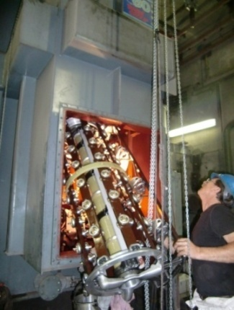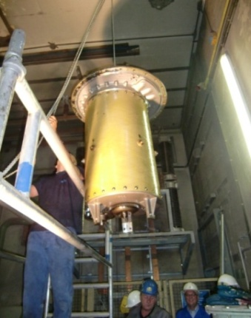

Figure7

OLTC replacement

**Motor-Drive Units**

* Reliable remote operation
* Transparent and modular design
* Integration into modern communication systems
* **Maintenance-Free** & protected

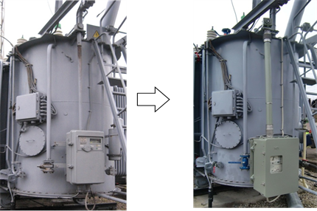

Figure 8

Motor-drive unit replacement

**Gauges and Measurement Systems**

* Calibration & **Maintenance-Free**
* Precise and reliable technology
* Advanced cooling control
* Communication with modern control system

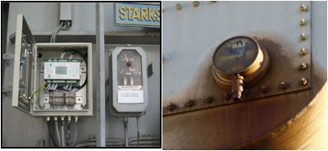

Figure 9

Temperature Control Systems

**Protection system**

* Approved protection, maximum safety
* No false alarms
* Optimal characteristics / setting options
* Test options

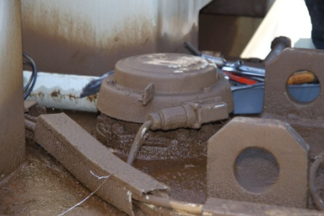

Figure 10

Leaking PRD

**Voltage Regulators including Monitoring functions**

* Integration into modern control system (IEC61850)
* Individual hardware configuration for flexible functions
* Reliable and most efficient operation of the transformer system
* Cost saving due to intelligent regulation

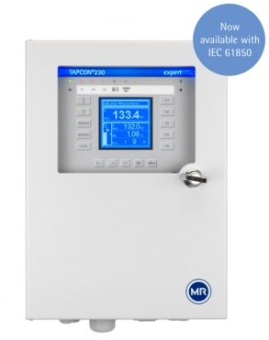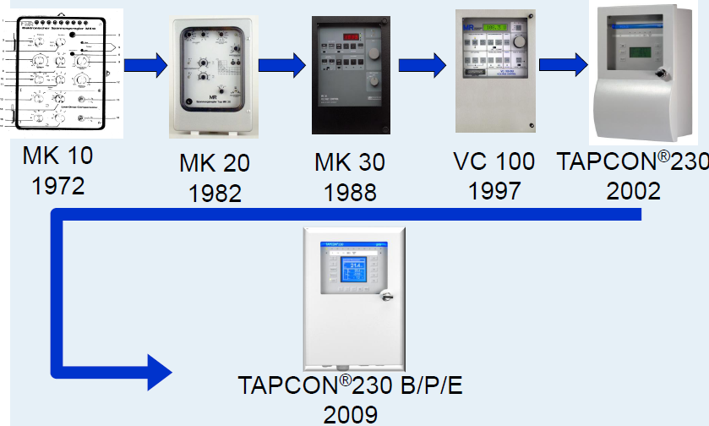

1980 2012

Figure 11

Voltage regulators

**Dehydrating Breather Systems**

* More efficient dehydration
* Extension of transformer life
* **Maintenance-Free** system; increased operating reliability
* Much less operating costs

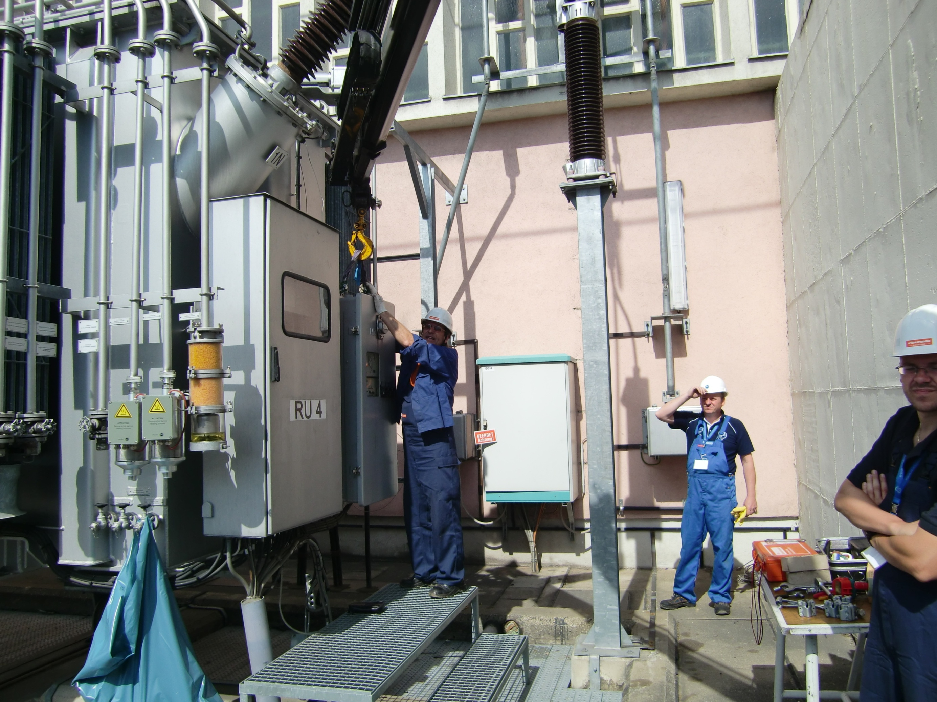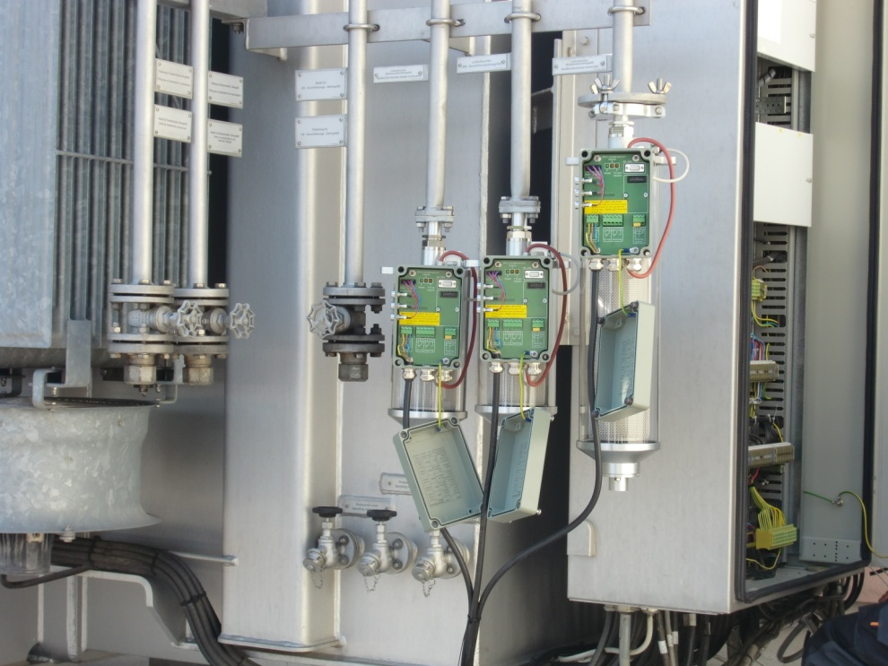

Figure 12

Dehydrating breathers

**On-line Oil Filter Systems for conventional Tap-Changers operating in oil**

* Efficient oil cleaning
* Less carbonization and moisture
* Reliable operating system
* Pressure switch and manometer

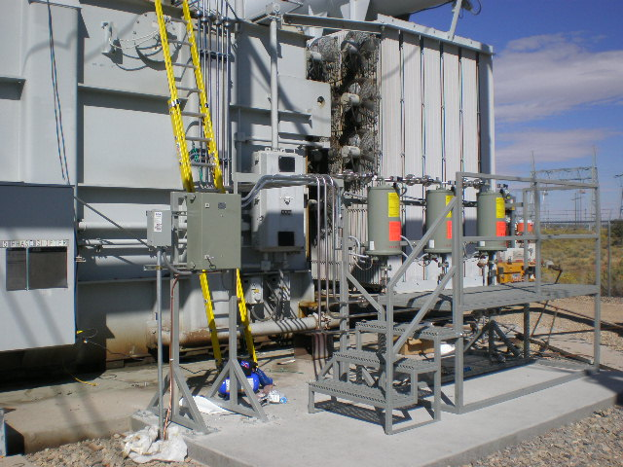

Figure 13

Oil filter systems for OLTC

**CONCLUSION**

Professional **Maintenance** and **Modernization** of transformers is a significant element in the lifecycle of transformers. Various reasons can be determined during transformer **Assessment**. Modifications based on the latest technical condition put the transformers on an up-to-date technical level so that they can be easily integrated in all modern substation networks. Such modified and upgraded transformers work reliably and efficiently like new systems.

Operation and **Maintenance** departments should invite experienced service partners in order to evaluate a clear and tailor-made **Asset-Management** Strategy.

LIST OF REFERENCES

1. CIGRE Working Group 2.34 – Guide for Transformer Maintenance
2. ABB Presentation TrafoAssetManagementTM Proactive Services
3. Siemens TLMTM <http://www.siemens.com/energy/TLM>
4. Maschinenfabrik Reinhausen GmbH, Johannes Gebauer, Servicekonzept an Stufenschaltern – Erfahrungen aus der Praxis
5. Maschinenfabrik Reinhausen GmbH, Johannes Gebauer, Tailor Made Solutions for Transformer, Modernization

1. Werner Fleischmann, Maschinenfabrik Reinhausen GmbH – MR, Falkensteinstrasse 8, 93059 Regensburg, GERMANY